

Project Name: Connect to Organic Salon

Branch PG-DAC Sep-2021

Documentation On

**“Connect to Organic Salon”**

PG- DAC SEP2021

Submitted By

**Group No: 23**

**Project Member:**

**Tejas Sonawane 210943120103**

**Shrihari Awate 210943120019**

**Shreya Zade 210943120095**

**Sajjan Sorate 210943120105**

**UNDER THE GUIDENCE OF:**

Mrs. Harshita Maheshwari

Faculty Member

Infoway Technologies, Pune

**Table of Contents**

|  |  |  |
| --- | --- | --- |
| **1** | **INTRODUCTION** |  |
|  | 1.1. Problem Definition |  |
|  | 1.2. Objective of Project |  |
| **2** | **Feasibility Study** |  |
| **3** | **Analysis** |  |
|  | 3.1. Existing System |  |
|  | 3.2. Proposed System |  |
|  | 3.3. Software Requirement Specification |  |
| **4** | **Design** |  |
|  | 4.1. UML diagrams |  |
| **5** | **Implementation** |  |
|  | 5.1. Modules |  |
|  | 5.2. Module description |  |
|  | 5.3. Introduction of technologies used |  |
| **6** | **Test cases** |  |
| **7** | **Screenshots of Webpages** |  |
| **8** | **Conclusion** |  |
| **9** | **Future Enhancement** |  |
| **10** | **Bibliography** |  |

**1.INTRODUCTION**

The need for hairdressing, grooming, facials, and related services will not decline as long as people live on this earth. In fact, in this age of fashion and corporate culture, people are more interested in grooming themselves than ever before. So, the beauty salons and hairdressing businesses are always on the rise.

As we can see during this pandemic situation the zero contact policy is much more needed, there is no automated system for the people’s who prefer local salons for doing all the grooming and facial related things. Having that in mind, for the people in need of websites for such businesses, so we present you **Connect to organic salon system**. Where we can have home service and salon service where people can book salon appointment with their respective local salon owners and can go with their given time slot where they have reserved seat for particular service also they can book home service for their little ones and old parents

**1.1 Problem Statement**

Existing system of a Salons is based on our traditional way of booking appointments by being present on time. We can see that there are some other salon websites were they are providing the service but the employee they send were not familiar or trustworthy as we can’t let anyone to enter our house ,the employee is going to spend some time in our house ,if we book service for our parents or children they are going to with at least for half an hour so their safety is at most important and also during these pandemic situation the salons can’t be filled with people waiting in the multi-colored chairs lined up against the wall. Hair salons, can be challenging to maintain proper social distancing and infection prevention measures. The close, face-to-face contact that the work requires for a prolonged period of time, increases risk. So avoid all these risk we need a system which takes care of these points and provide customer with good services and with better convenience.

**1.2 Objectives of project-**

Specific goals are: -

* Taking the problems under consideration our objective is to provide people such a system where they will have services quality and employees of their own choice which we give them comfort and also build more trust between salon and customers
* To produce a web-based system that allows the customer to book Salon appointment online. Salon owner can view the list of appointments of customer and also can add, update and delete the services.
* To fill the communication gap between customer and salon owner.
* The customer can make a book appointment with the preferred salon with his preferred employee .
* We value time of our Customers who are working or have some important meeting to do so we provide quick and satisfactory service to the customers.

**2. Feasibility Study**

For any proposed System most, important factor is resource gathering and time management for successful execution of project in time.

We started gathering the information about how people in salons require a change in the daily routine of there seating in queue for minutes and hours for their turn, so their response was they have to go for another work also how nice it would be if they can book the seat for a particular time and same situation was for people who want home service they don’t want to get out of there home and also wants safety.

We calculated normally how much time is required for a particular service to get executed and at time slot customer demand is more which service is taken on regular basis in salons how salon owners manage their employees and assign task to them on and the need of the customer how they are comfortable with the particular employee for them they wait when he will get free and we can take service from him. So, the time required is nearly half hour for normal and for any stylish hair cut and for spa and massages it normally 1 hour and for hair keratin and hair smoothening like services its normally 2 hours.

Now for home service the people who want home service will require same amount of time by employees to execute the service but the time will be going to waste to reach at employee’s house and to come back to salon or to reach at another customer for travel it will max 15-20 min for that time slot of 1hr will do if services are normal and for advanced and time consuming 15-20 min additional according, we planed service time for home and salon service

After gathering all information, we are given 120 hours for project execution we have planed our projects hours accordingly what modules will need more hours as salon owner’s module (shopkeeper) will require more numbers of hours as he has the services slots and employee to manage so 40 hours for that then 20 hours for customers and for admin 20 hours and for testing and errors and resolving 40 hours**.**

**3.Analysis**

**3.1. Existing System**

* In the Existing system we have sites who provide home services but the employee they provide were not from any salon also they are not familiar and we don’t know about their professional experience in the service which they are providing.
* In existing system the service providers uses products what they want.
* Existing websites and other online sites don’t have any service or place on site where people can buy salon products.
* If people want to go outside and have some work and also want to have haircut but they have to wait in a queue for their turn to get haircut or any service.

**3.2. Proposed System**

* Looking at the problems in existing system we thought of providing such a service to peoples were people can have a friendly atmosphere and can enjoy service without wasting time by seating in a queue or by spending time at home with unknown employee about whom the customer don’t know any thing neither about his professional experience nor about his personal background.
* For providing such system we have some services and option which are customer friendly and we have kept the option keeping their needs and facilities in point of view .
* Our Connect To Organic Salon website provides home and salon service to customers where they can book appointments and can take service and select employees of there choice in simple and easy way.
* Our website system has a simple and customer friendly UI design . Customer can book the appointment with the local salon according to their area and location .
* He can also select more than one service at a time with the time slot he wants and can select the employee he is comfortable with.
* Customer can also have a look to our organic products for this they don’t need to login to view our products, we are one stop solutions were we provide organic products for customer to buy and also at a reasonable price.
* Customer can also give review about the service’s and also about the employee from whom he had the service.
* Connect to Organic Salon System provides the features for admin, salon owner, employee and customer were salon owner can have a record of his employees appointment and can manage his employees and also can add multiple services and add time slot for customers .

**3.3. Software Requirement Specification**

**Hardware:**

1. Intel i3 processor 3rd generation or later / AMD Ryzen 200 2nd generation or later

2. 2 GB ddr3 ram.

3. Windows 7 Home edition or later.

4. 200 GB Sata HDD Space

5. Data Connection 200 kbps

**Software:**

* **Back End:**

Framework Spring Boot

ORM Tool Hibernate

Database MySQL

Build Tool Maven dependencies

Language Java

* **Front End:**

HTML

CSS

JavaScript

Bootstrap

**4. Design**

## **ER Diagrams**

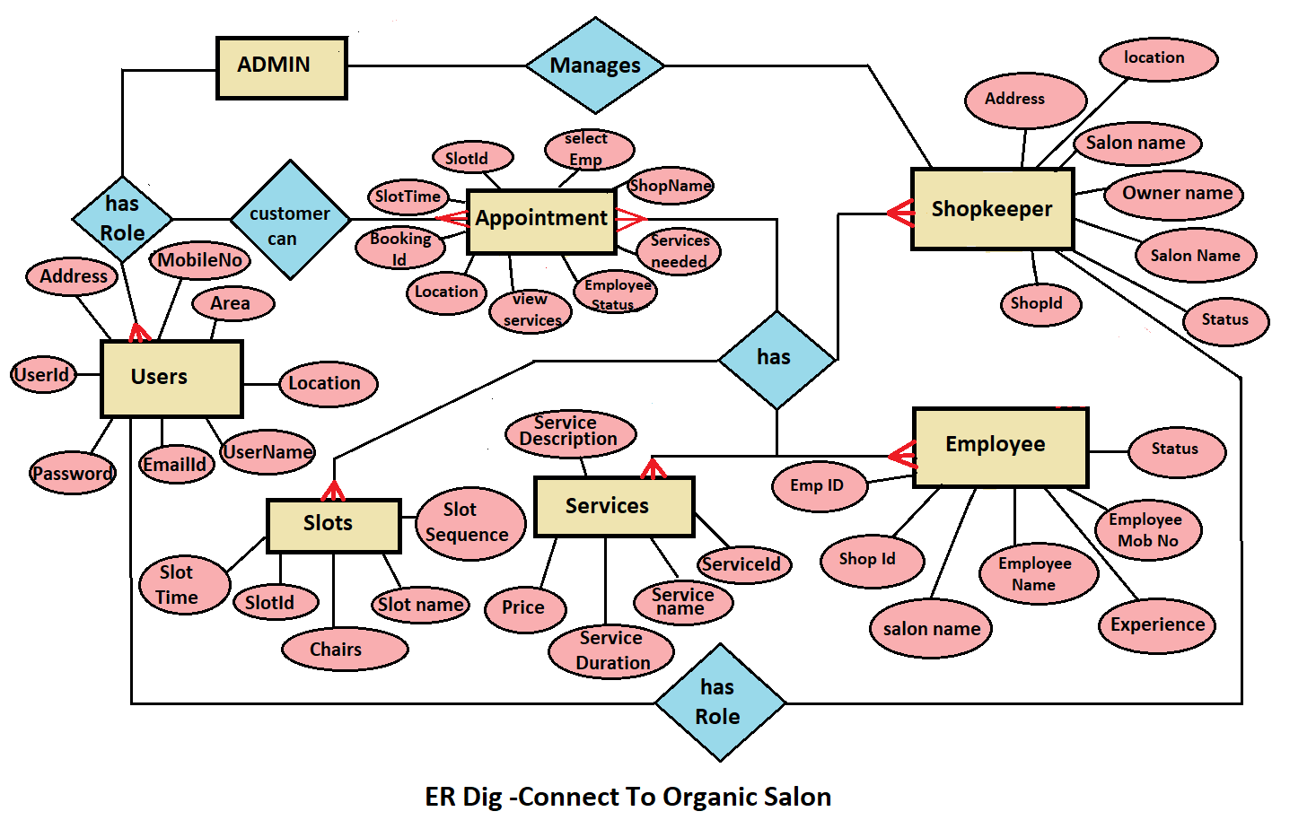

## **EER Model Dig**

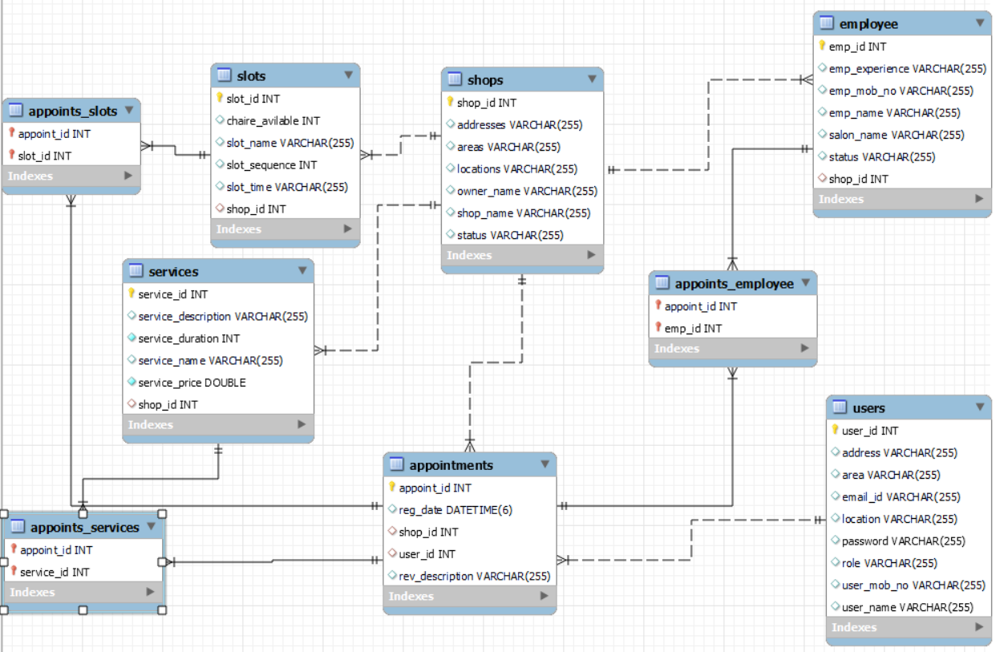

**EER Model Dig**

**4.1. UML diagrams**

**(1) UseCase Diagram**

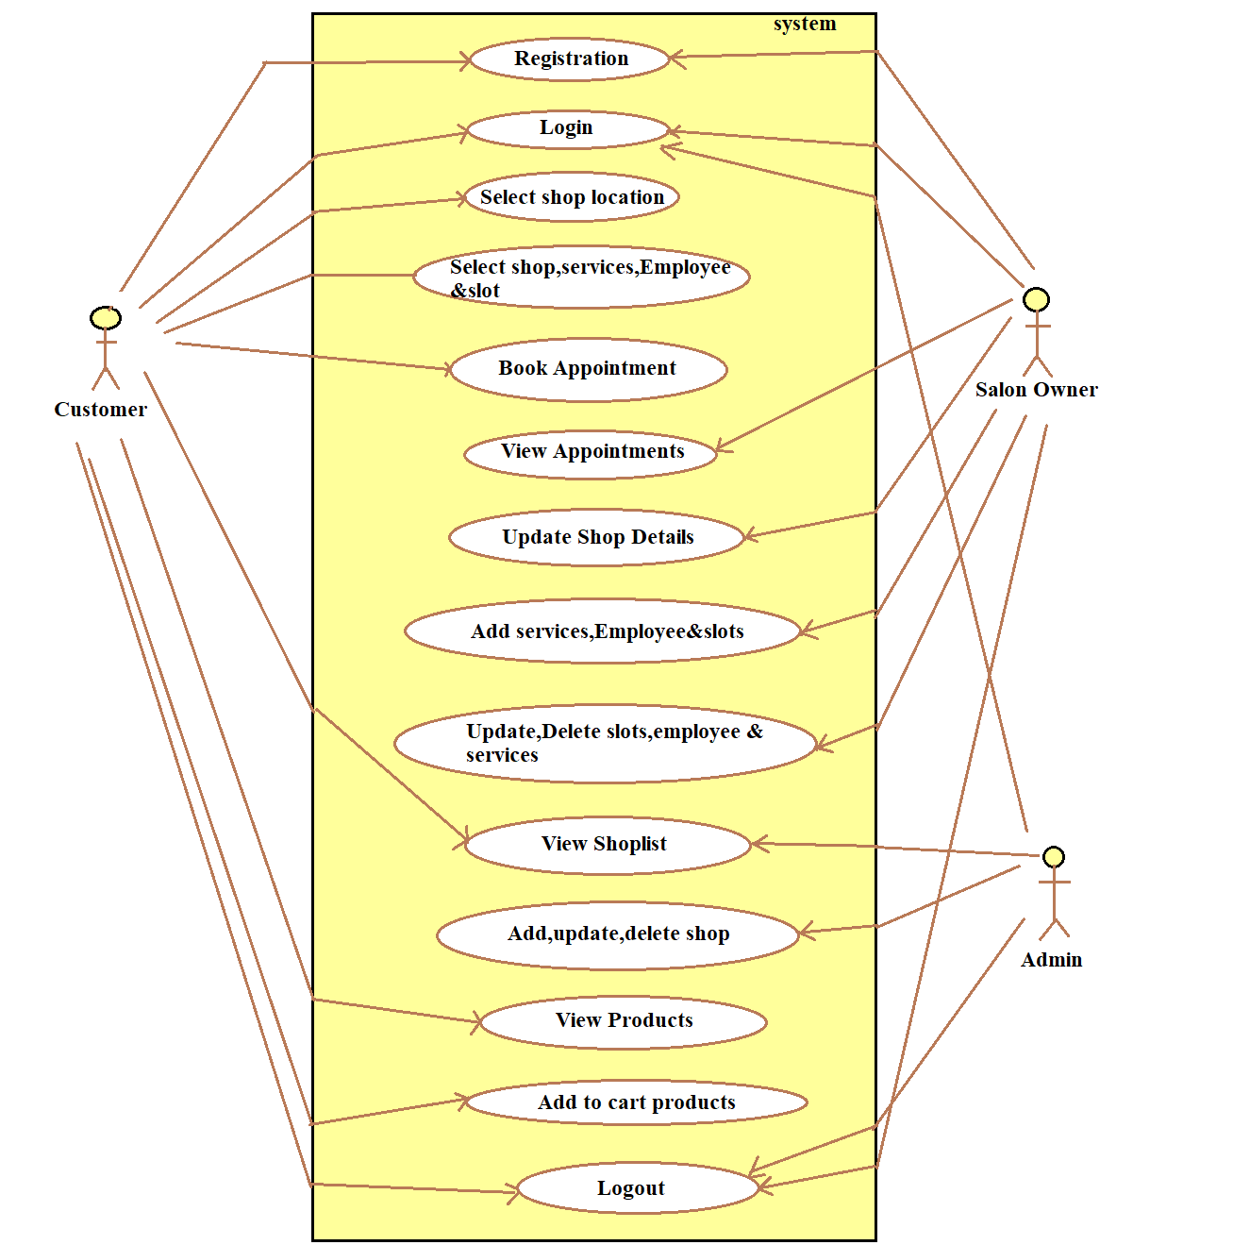

**Diagram. UseCase Diagram**

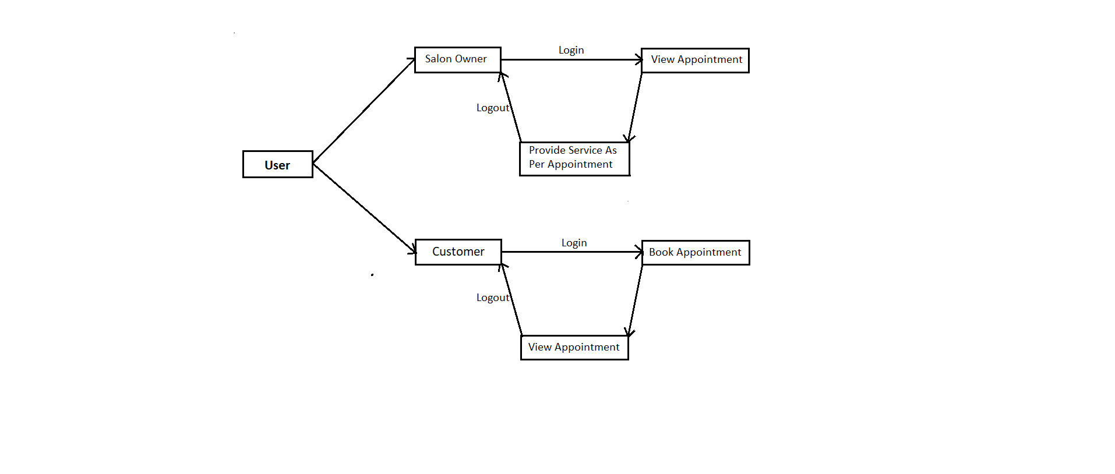

**Diagram. Collaboration Diagram**

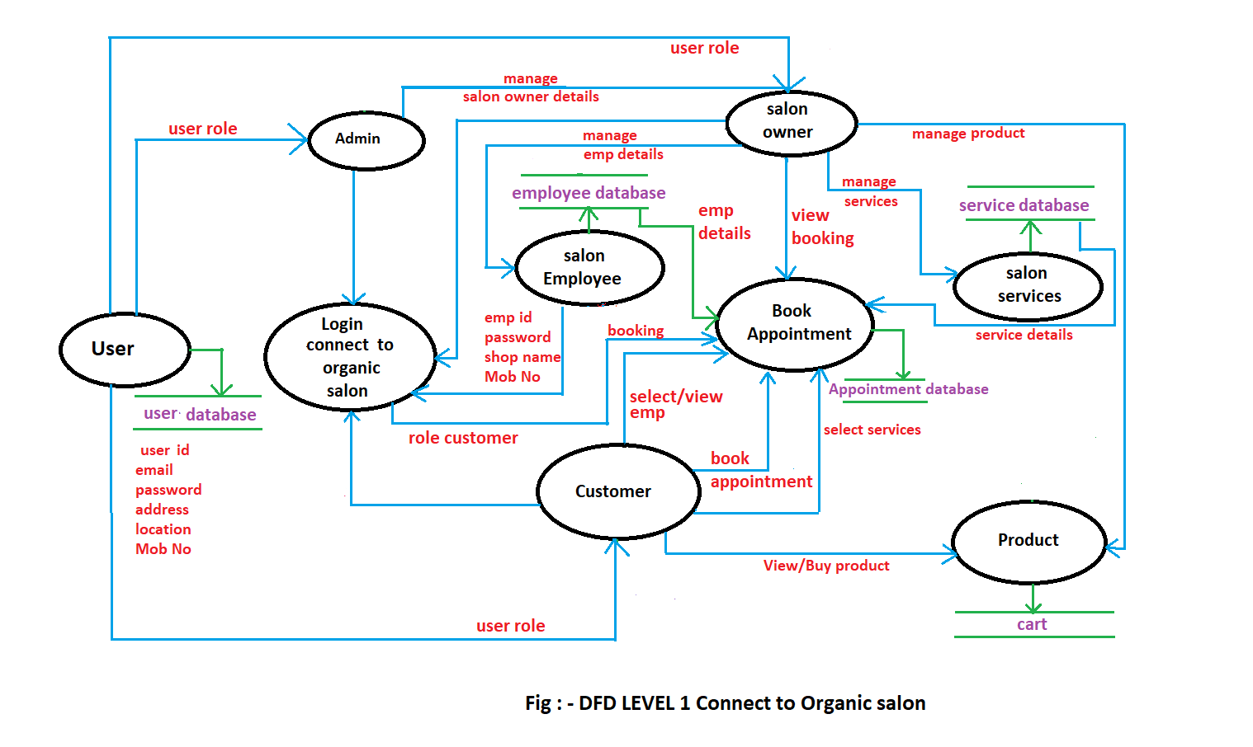

**Diagram. Sequence Diagram**

**5. Implementation**

**5.1. Modules**

Our proposed system i.e. Connect To Organic salon consists of three modules listed as below.

1. Admin Module

2. Customer Module

3. Salon Owner Module

**5.2. Module description**

**Admin Module**

* Admin can login to the system.
* View the list of all the register salon.
* Add new salon.
* Delete salon.
* Update salon details.

**Customer Module**

* Customer can login to the system.
* Select the salon location
* Can view list of salons at that location.
* Can select the salon.
* From selected salon can select multiple services.
* After selecting services he can select time slot.
* can select the employee
* Can book the appointment.
* view product
* can add product to cart.

**Salon Owner Module**

* Salon owner can login to the system.
* View appointment list.
* Add new services.
* Update services.
* Delete the services.
* Add new time slot.
* Update time slot.
* Delete time slot.
* Add new employee
* Update employee
* Delete Employee

**5.3. Introduction of technologies used**

* **Spring Boot Framework:**

Spring Boot is a project that build on the top of Spring Framework. It provides an easier and faster way to set up, configure, and run both simple and web-based applications.

It is a Spring Module that provides the RAD (Rapid Application Development) feature to the Spring Framework. It is used to create a stand-alone spring based application that we can just run because it needs minimal spring configuration.

**1.1 Features of Spring Boot Framework:**

* **Web Development:**

It is well suited module for web application development. We can easily create a self-contained HTTP server using embedded servers like Tomcat.

* **Spring Application:**

It is a class which provides the convenient way to bootstrap a spring application which can be started from main method. We can call start our application just by calling a static run() method.

* **Application Events and Listeners:**

Spring Boot uses events to handle variety of tasks. It allows us to create factories file that are used to add listeners. We can refer it by using Application Listener key.

* **Admin Support**

Spring Boot provides the facility to enable admin related features for the application. It is used to access and manage application remotely. We can enable it by simply using spring.application.admin.enabled property.

* **Properties Files**

Spring Boot provides rich set of Application Properties. So, we can use that in properties file of our project. Properties file is used to set properties like: server.port = 8080 and many others. It helps to organize application properties.

* **Logging**

Spring Boot uses Common logging for all internal logging. Logging dependencies are managed by default. We should not change logging dependencies, if there is no required customization is needed.

* **Security**

Spring Boot applications are spring based web applications. So, it is secure by default with basic authentication on all HTTP endpoints. A rich set of Endpoints are available for develop a secure Spring Boot application.

**1.2 Advantages of Spring Boot Framework:**

1. It creates stand-alone Spring applications that can be started using Java -jar.

2. It tests web applications easily with the help of different Embedded HTTP servers such as Tomcat, Jetty, etc. We don't need to deploy WAR files.

3. It provides opinionated 'starter' POMs to simplify our Maven configuration.

4. It provides production-ready features such as metrics, health checks, and externalized configuration.

5. There is no requirement for XML configuration.

6. It offers a CLI tool for developing and testing the Spring Boot application.

7. It offers the number of plug-ins.

* **Hibernate**

Hibernate is a Java framework that simplifies the development of Java application to interact with the database. It is an open source, lightweight, ORM (Object Relational Mapping) tool. Hibernate implements the specifications of JPA (Java Persistence API) for data persistence.

* **ORM Tool:**

An ORM tool simplifies the data creation, data manipulation and data access. It is a programming technique that maps the object to the data stored in the database. The ORM tool internally uses the JDBC API to interact with the database.

* **JPA:**

Java Persistence API (JPA) is a Java specification that provides certain functionality and standard to ORM tools. The javax.persistence package contains the JPA classes and interfaces.

**1.4 MySQL**

MySQL, the most popular Open Source SQL database management system, is developed, distributed, and supported by Oracle Corporation.

**Features of MySQL:**

* **MySQL is a database management system.**

A database is a structured collection of data. It may be anything from a simple Salonping list to a picture gallery or the vast amounts of information in a corporate network. To add, access, and process data stored in a computer database, you need a database management system such as MySQL Server. Since computers are very good at handling large amounts of data, database management systems play a central role in computing, as standalone utilities, or as parts of other applications.

* **MySQL databases are relational.**

A relational database stores data in separate tables rather than putting all the data in one big storeroom. The database structures are organized into physical files optimized for speed. The logical model, with objects such as databases, tables, views, rows, and columns, offers a flexible programming environment.

* **MySQL software is Open Source.**

Open Source means that it is possible for anyone to use and modify the software. Anybody can download the MySQL software from the Internet and use it without paying anything.

* **The MySQL Database Server is very fast, reliable, scalable, and easy to use:**

MySQL Server was originally developed to handle large databases much faster than existing solutions and has been successfully used in highly demanding production environments for several years. Although under constant development, MySQL Server today offers a rich and useful set of functions. Its connectivity, speed, and security make MySQL Server highly suited for accessing databases on the Internet.

* **MySQL Server works in client/server or embedded systems:**

The MySQL Database Software is a client/server system that consists of a multithreaded SQL server that supports different back ends, several different client programs and libraries, administrative tools, and a wide range of application programming interfaces.

**6. Test cases**

|  |  |  |  |  |  |
| --- | --- | --- | --- | --- | --- |
| **Test case id** | **Test case Name** | **Test case description** | **Expected Result** | **Actual result** | **status** |
| 1 | Admin Login | Admin needs to enter his id and password for login | Admin can see his homepage | Admin is on his home page | successful |
| 2 | Salon Owner Login | Salon owner need to register first and then enter his customer id and password for login . | Salon owner can see his appointments page. | Salon Owner on his Appointments page. | successful |
| 3 | customer Login | customer need to register first and then enter his customer id and password for login . | Customer can see his homepage | customer is on his home page | successful |
| 4 | Confirm appointment | Customer selects location, shop, slots, services, employee then only his appointment will confirm | Appointment will confirm and customer see Booking status is Confirmed. | Customer can see Appointment is booked. | successful |

**7. Screenshots of Webpages**

**Home Page:**

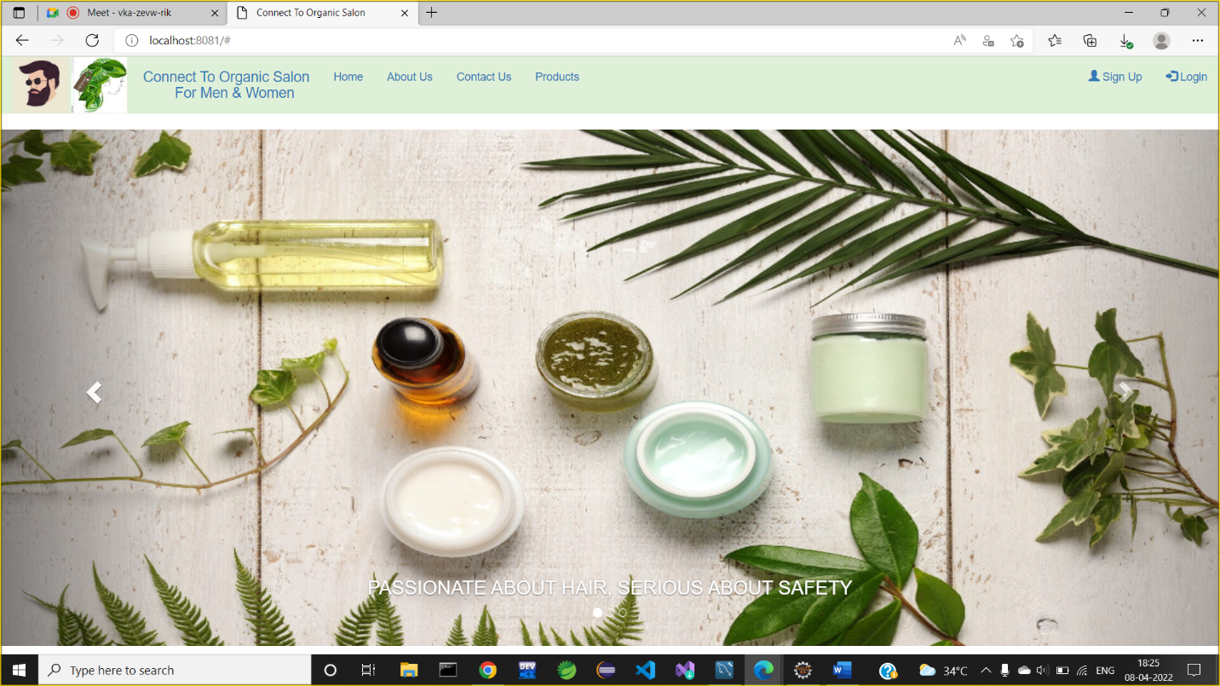

**Login Page:**

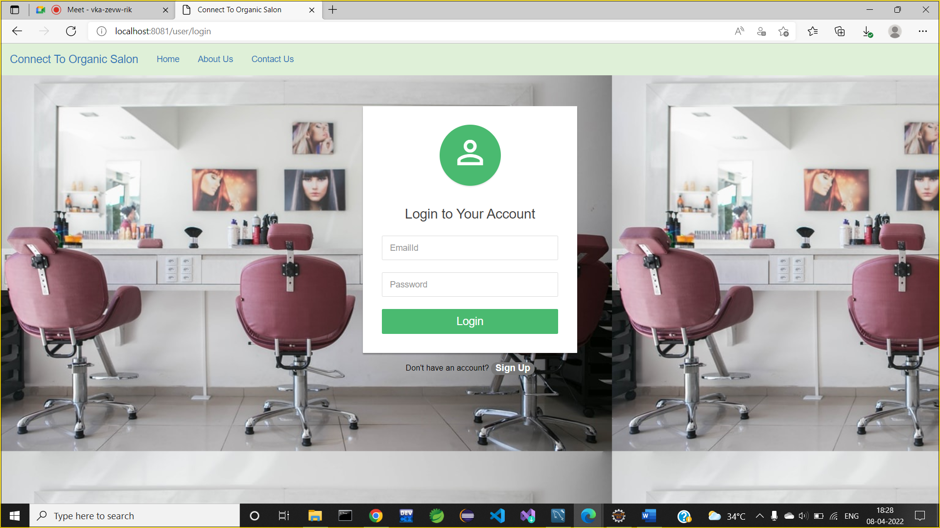

**Registration Page:**

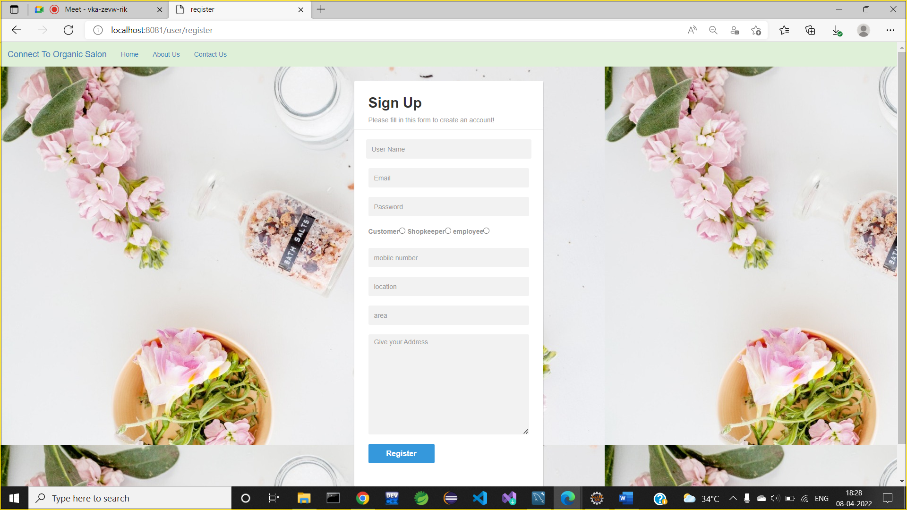

**Admin Functionalities:**

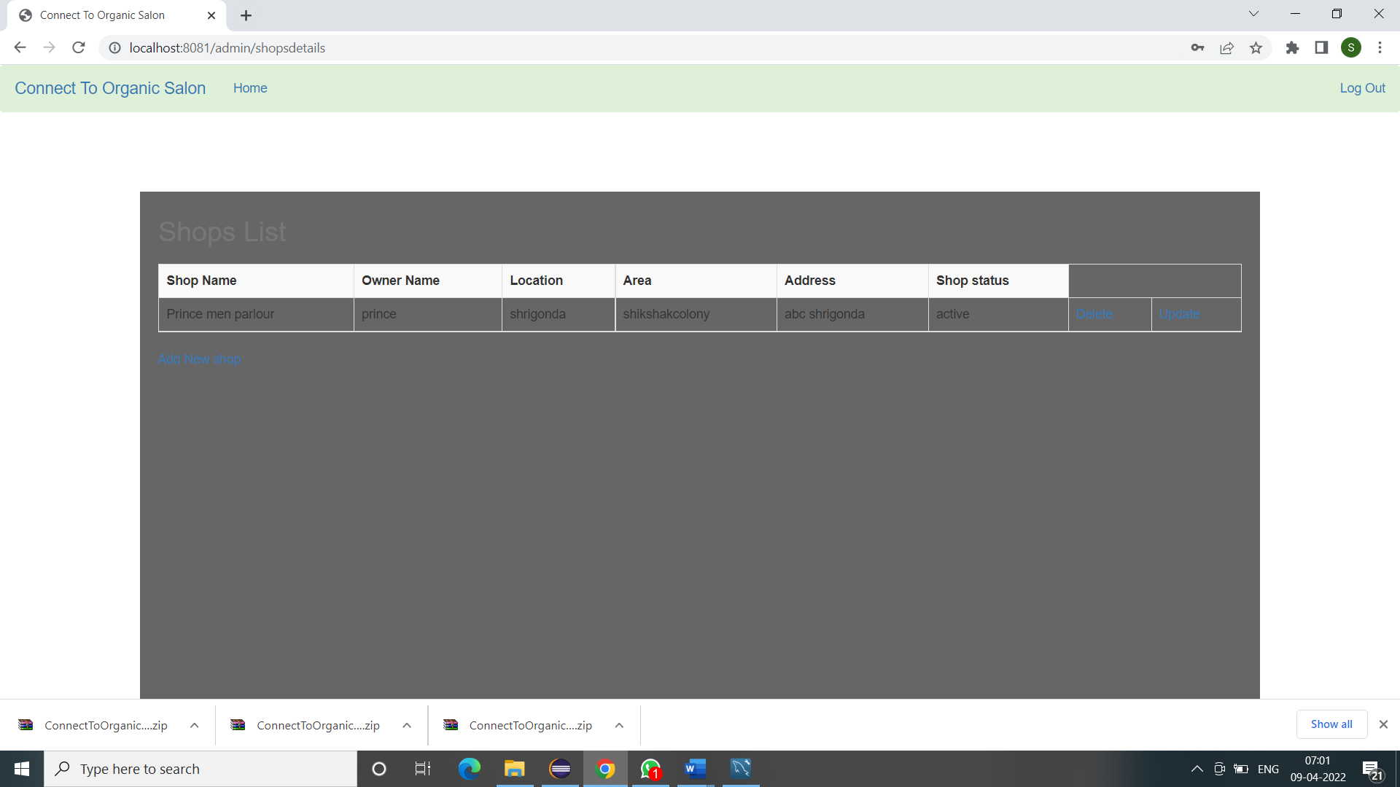

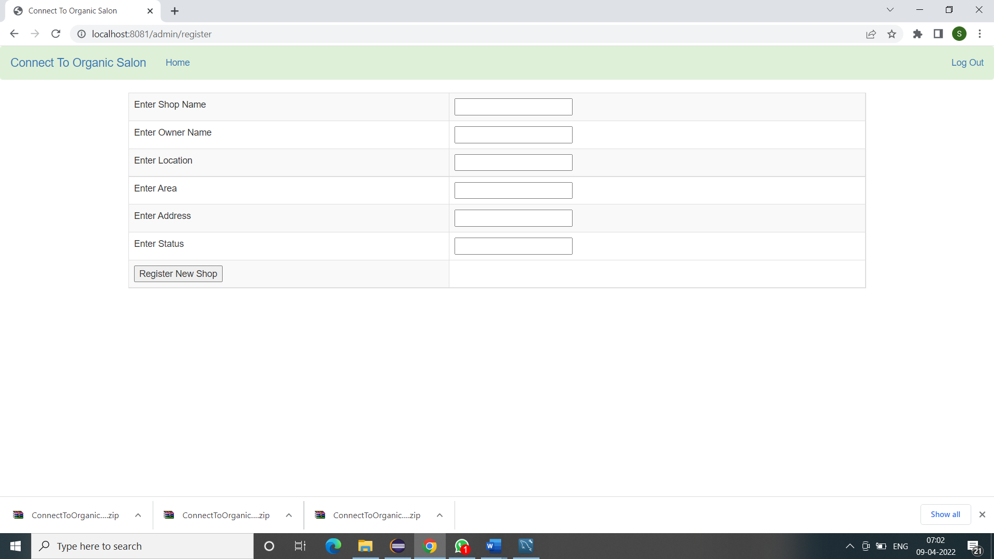

**SalonOwner Functionalities:**

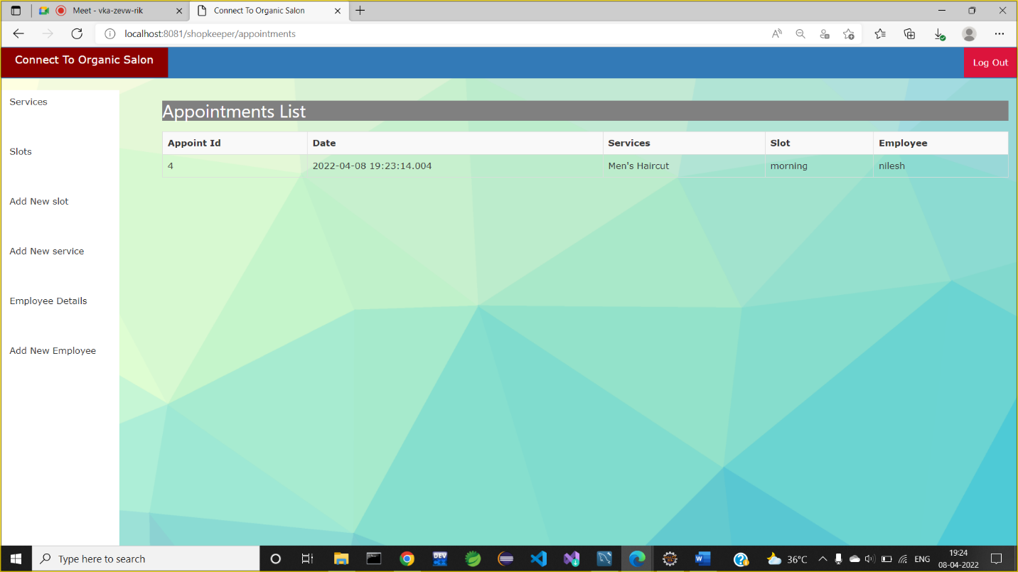

**Add New service:**

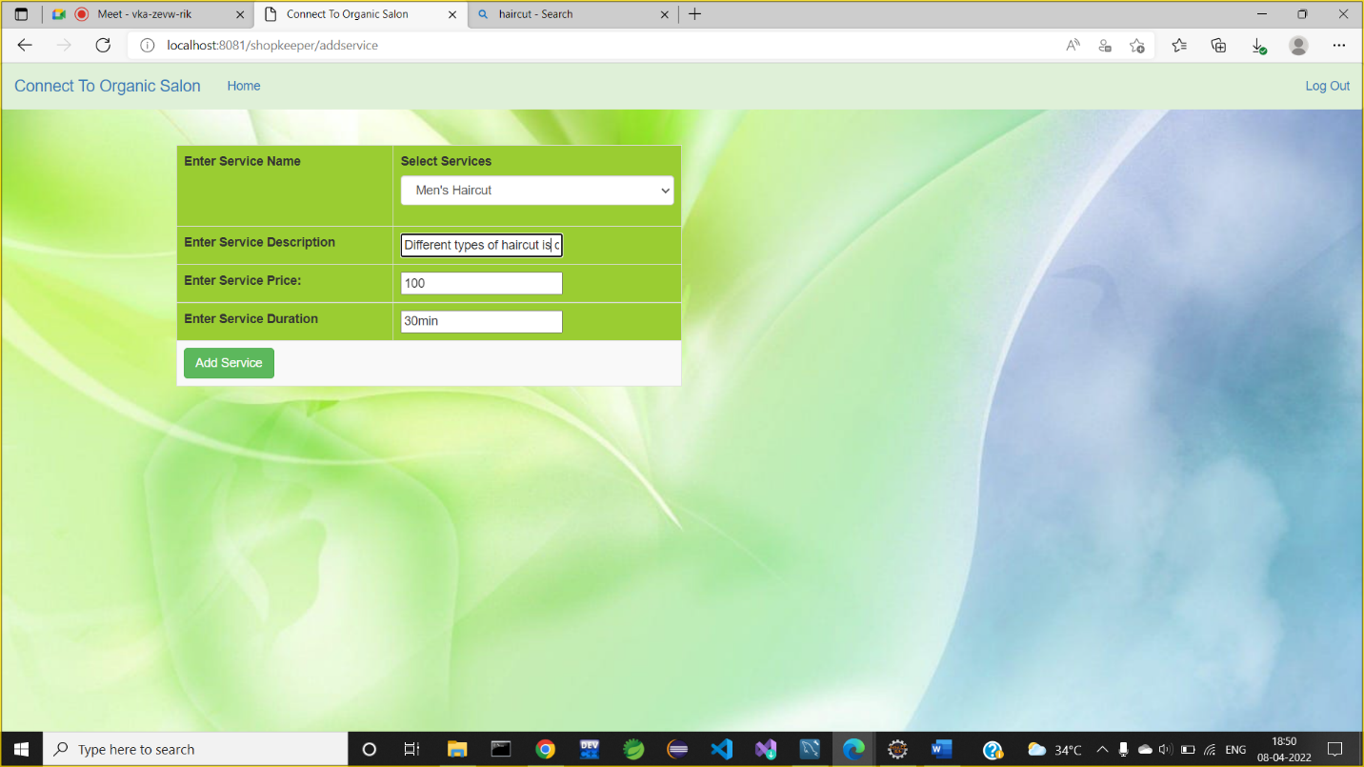

**Add New Employee:**

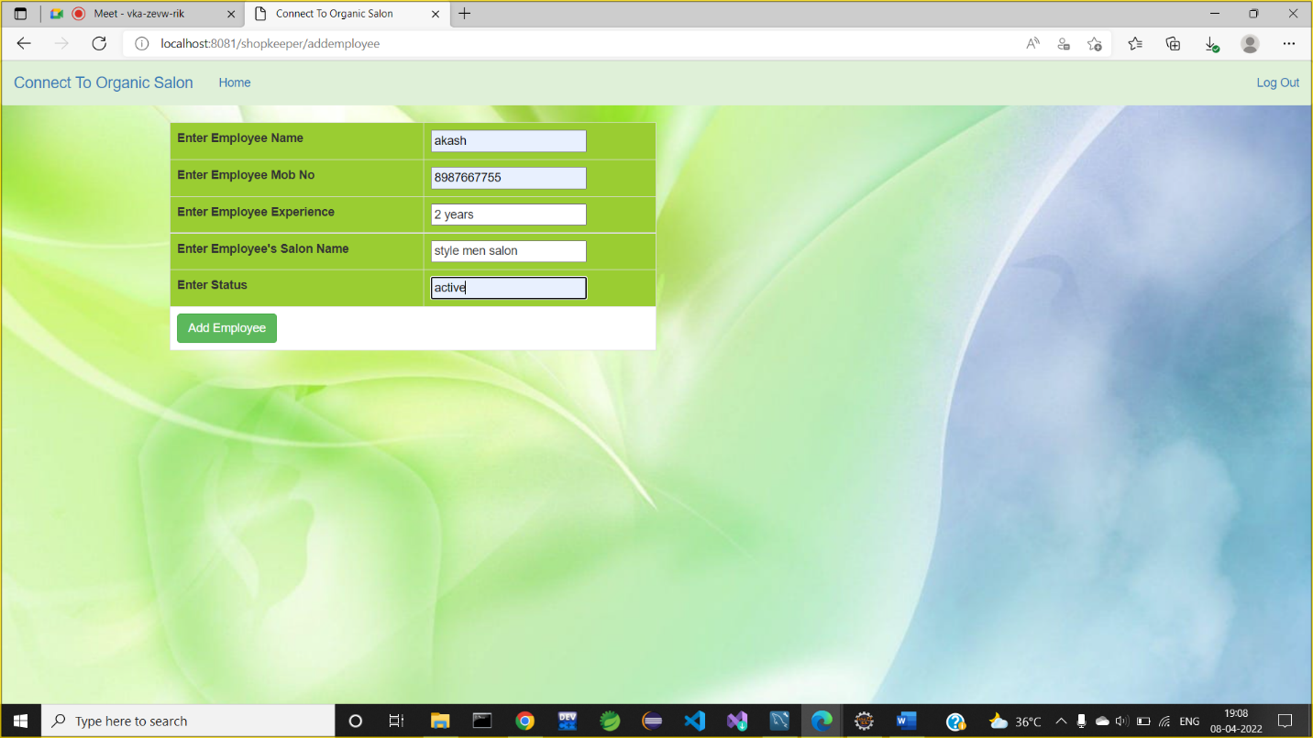

**Added Employee List:**

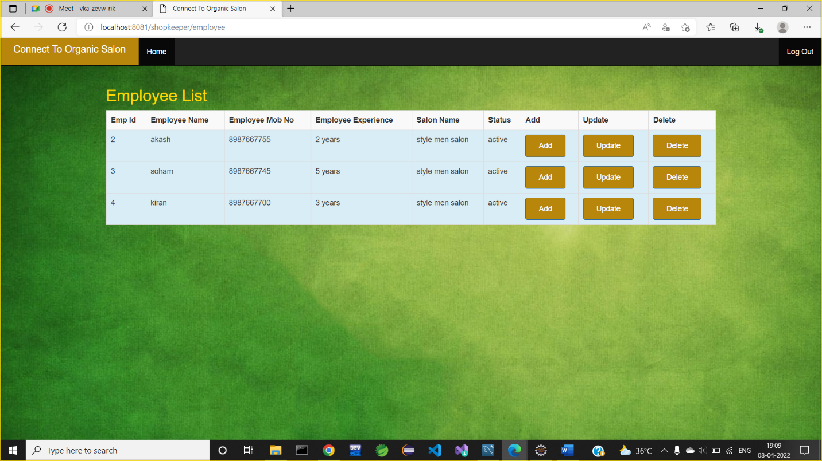

**Added Services List**:

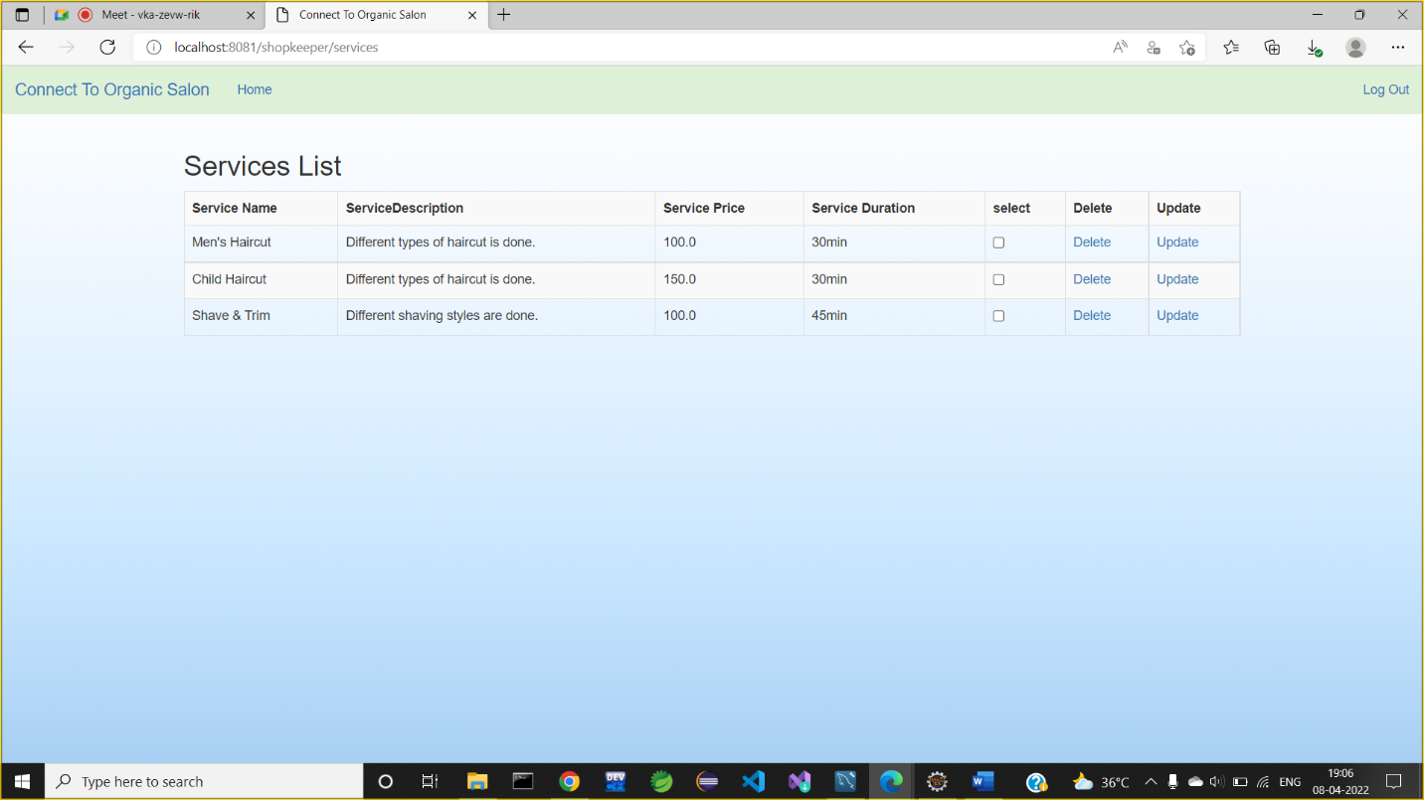

**Added Slots List:**

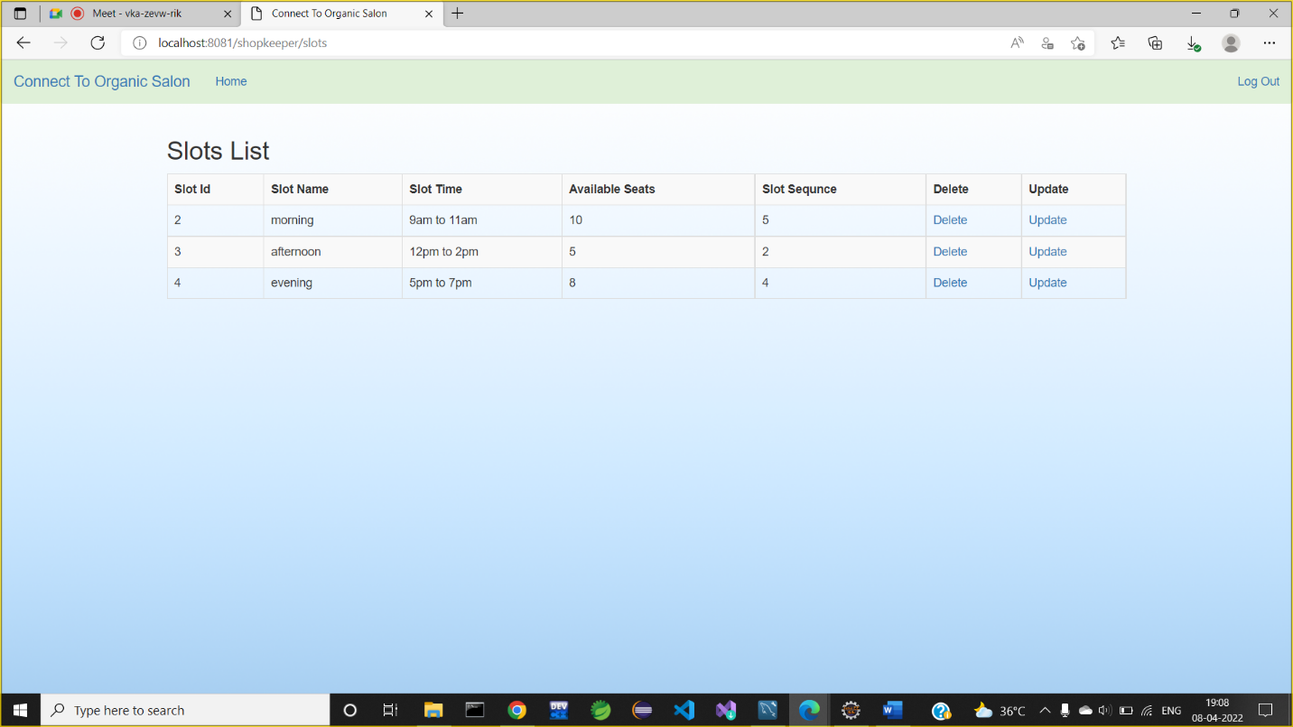

**Customer Functionality:**

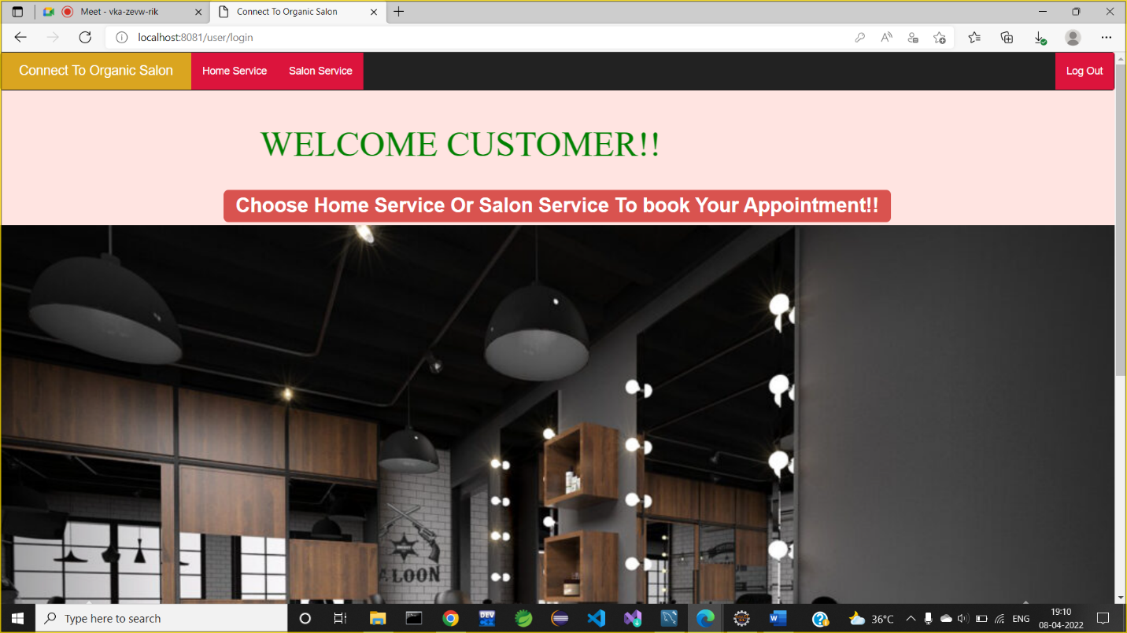

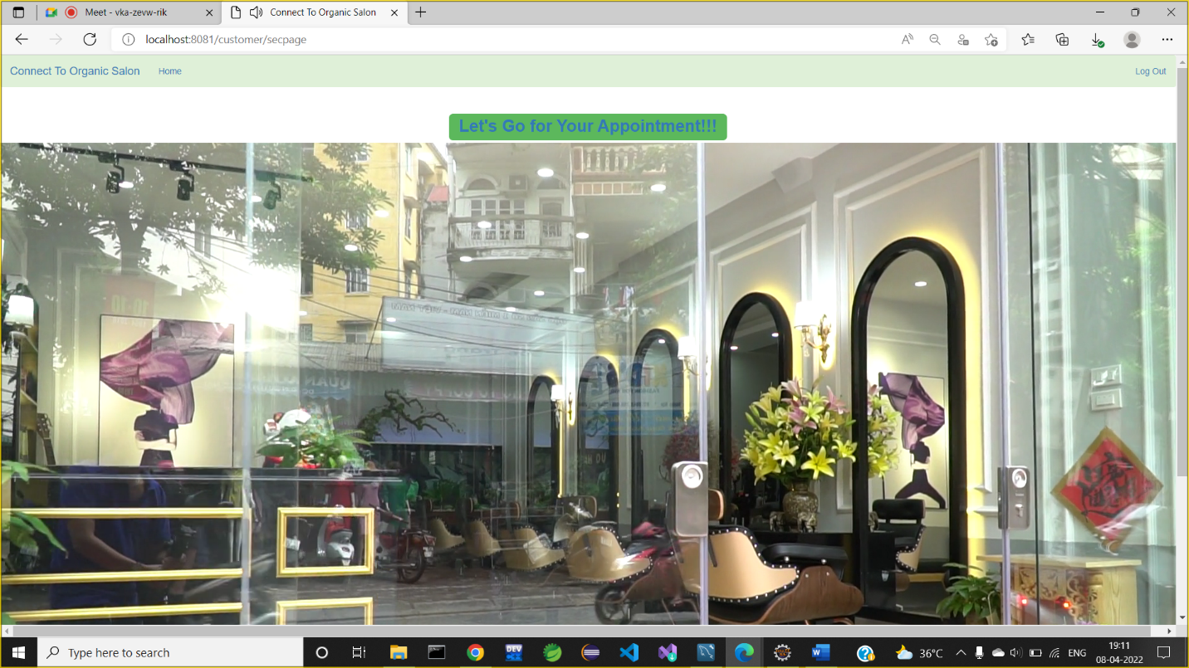

**Select Location:**

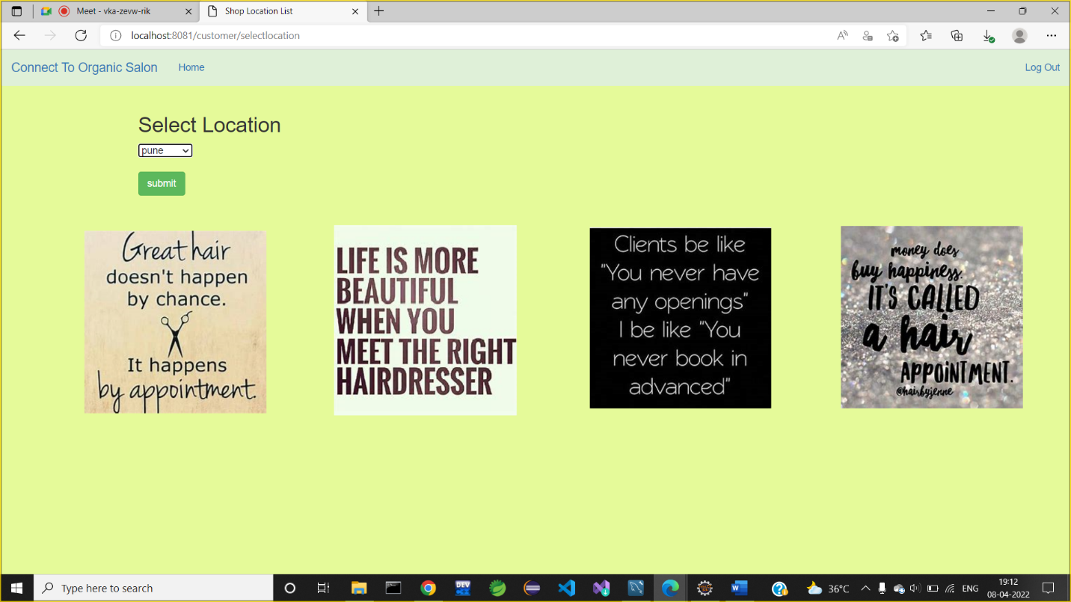

**Select Shop:**

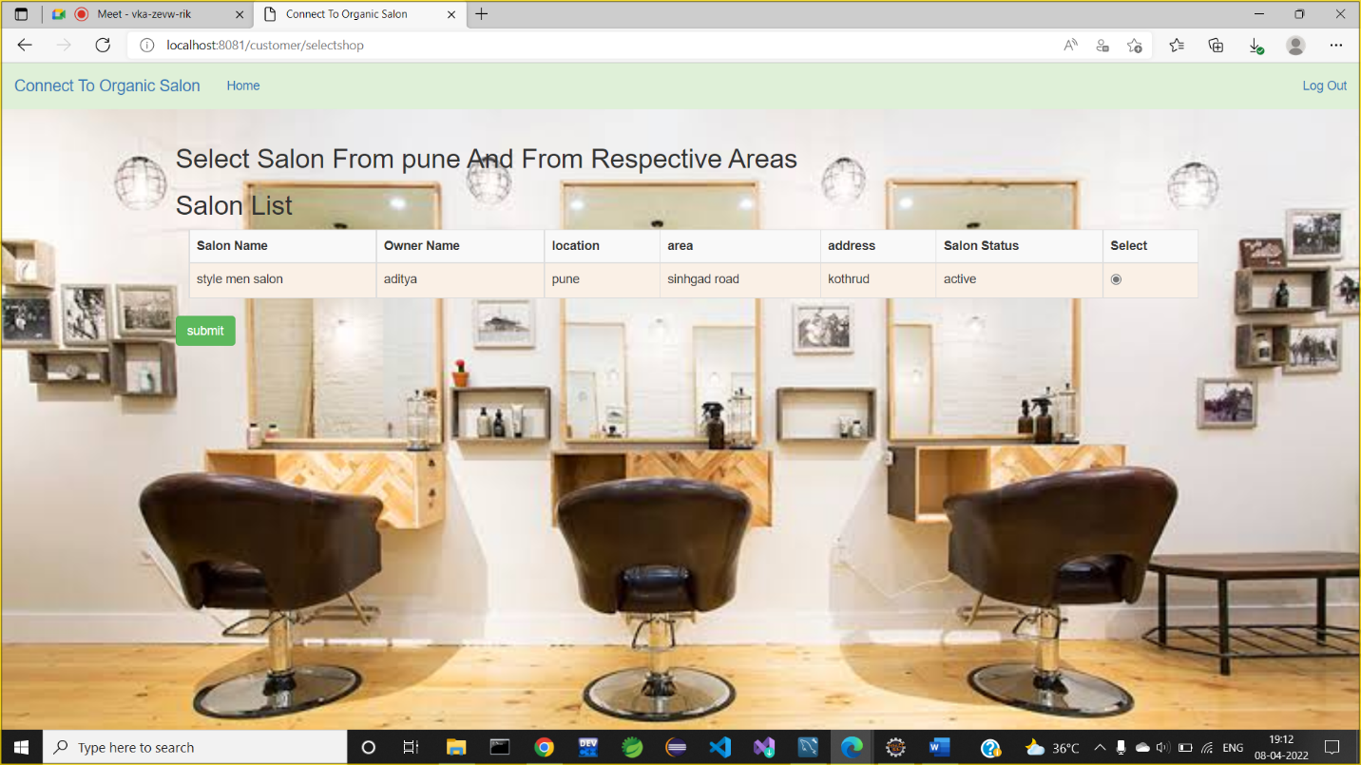

**Select Service and Employee**:

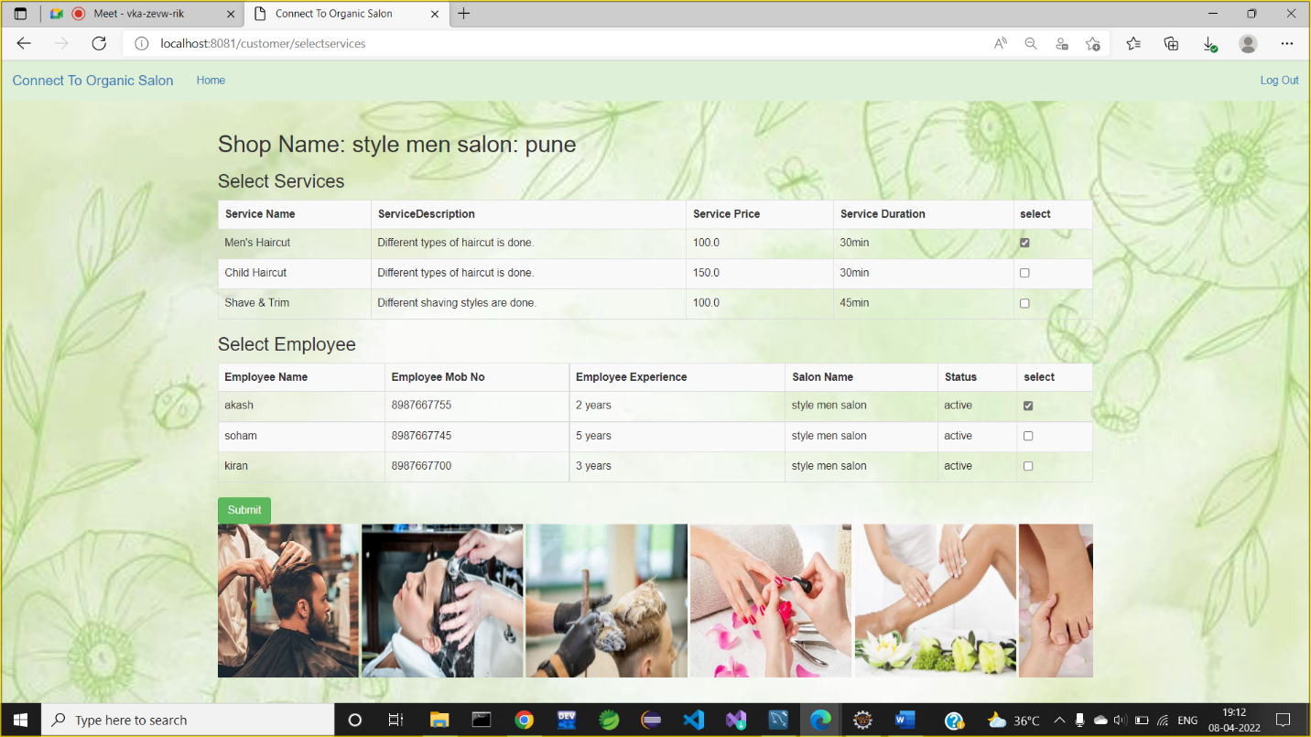

**Select Slot:**

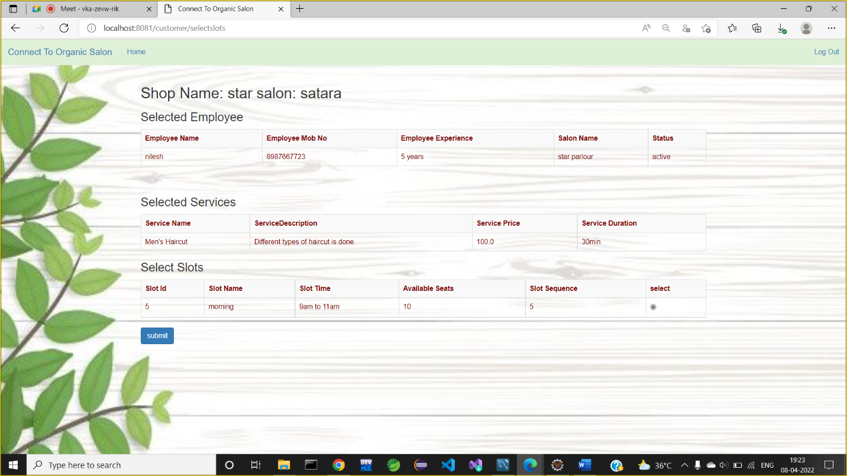

**Appointment Booked Successfully:**

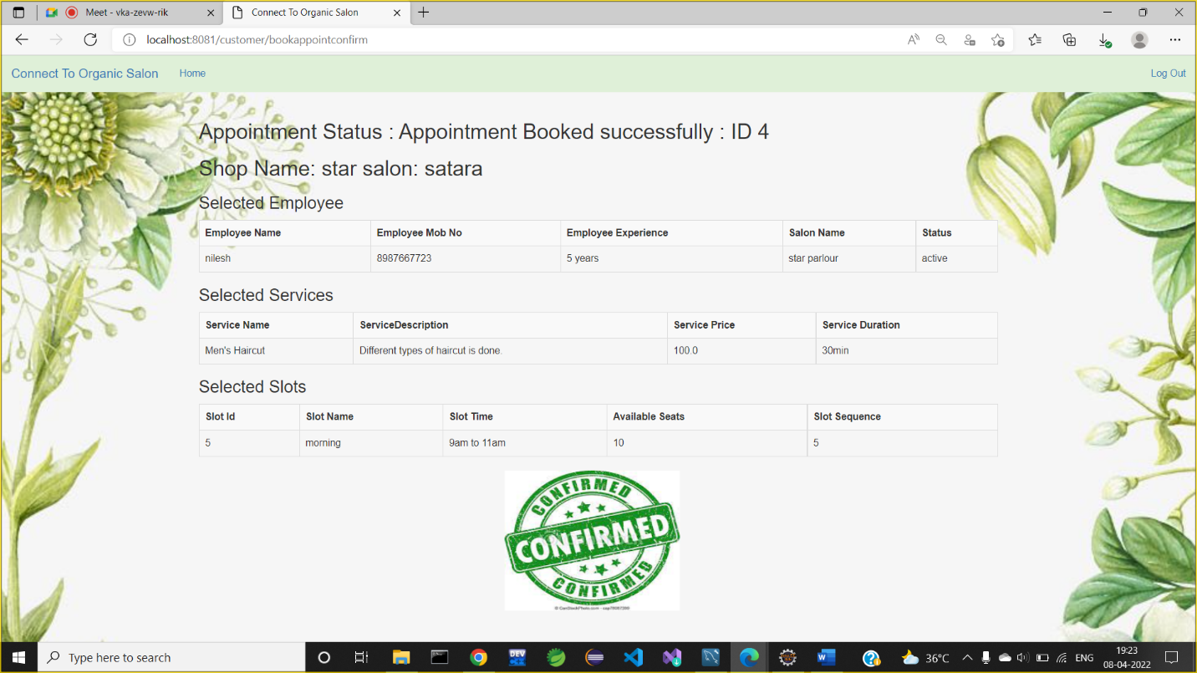

**8. Conclusion**

Connect to Organic Salon system is responsible for providing best services, flexible time slot and daily services and time changes with the affordable prices on specified. This approach also offers an added advantage that customers can select a specified time slot of the day for the appointments of salon. The application provides facility to add/remove/slot and services items at salon. It also provides facility where customers can mention their queries/complaints in reviews. Application provides safety and reduces risk during the pandemic situation.

**9.Future Enhancement**

This project can be enhanced further by adding other categories and Services. The software is flexible enough to be modified and implemented as per future requirements. Message and Email alerts for various happenings can be added to the system so that users do not miss the updates and happenings of the system. Also more variety of products and UPI payments can be also added.

**10. Bibliography**

[1]. Kirti Bhandge, Tejas Shinde, Dheeraj Ingale, Neeraj Solanki, Reshma Totare,”A Proposed System for Touchpad Based Barber shop System Using Android Application”, International Journal of Advanced Research in Computer Science Technology (IJARCST 2015).

[2]. Varsha Chavan, Priya Jadhav,Snehal Korade,Priyanka Teli, ”Implementing Customizable Online Barber shop System Using Web Based Application”, International Journal of Innovative Science, Engineering Technology(IJISET) 2015.

[3]. [**https://www.javatpoint.com/spring-boot-tutorial**](https://www.javatpoint.com/spring-boot-tutorial)

[**https://www.w3schools.com/REACT/DEFAULT.ASP**](https://www.w3schools.com/REACT/DEFAULT.ASP)

[**https://www.javatpoint.com/mysql-tutorial**](https://www.javatpoint.com/mysql-tutorial)

**Thank You!**